Dominic Bumpus Input Design Exercise
Dominic Bumpus
Trine University
SYS—5013-301
Dr. Kelly Wibbenmeyer
October 10, 2025

Introduction
Hospitals face increasing challenges in managing patient inflows efficiently, particularly during peak check-in hours. Sunrise Hospital aims to streamline its patient check-in process through a user-friendly input system that ensures accuracy, reduces redundancy, and minimizes wait times. Effective input design requires careful attention to user interface layout, validation rules, and error prevention mechanisms. This paper proposes an efficient input system design for Sunrise Hospital’s patient registration process that balances usability, accuracy, and speed.

Input System Design

User Interface Layout
The input interface is divided into five structured sections, each with clearly labeled fields:
- Patient Identification
  - Patient ID (auto-generated, read-only)
  - Full Name (text field)
  - Date of Birth (date picker with age auto-calculation)
- Medical History
  - Allergies (multi-select or checkboxes with free-text option)
  - Current Medications (text box with autocomplete suggestions from hospital database)
  - Preexisting Conditions/Surgeries (dropdown and optional free-text entry)
- Appointment Details
  - Appointment Date & Time (date-time picker, future dates only validation)
  - Department/Specialist (dropdown menu)
  - Reason for Visit (text field)
- Insurance Information
  - Insurance Provider (dropdown or type-ahead search)
  - Policy Number (text field with format validation)
  - Co-Pay Amount (numeric field with currency validation)
- Emergency Contact
  - Contact Name (text field)
  - Relationship with Patient (dropdown: spouse, parent, sibling, friend, etc.)
  - Phone Number (numeric field with validation for format)

Validation Checks
- Date of Birth: Prevents future dates.
- Appointment Date: Must be set in the future (no past dates).
- Phone Number: Validation for proper format.
- Policy Number: Must match patterns of insurer requirements.
- Required Fields: Highlighted with a red asterisk to prevent incomplete submissions.
- Duplicate Records: Patient ID cross-check to avoid multiple records for the same individual.

Design Choices and Rationale
- User-Friendliness: The design uses dropdowns, auto-complete fields, and checkboxes to minimize typing and accommodate patients of different age groups.
- Efficiency: Auto-generated Patient ID and auto-fill features reduce repetitive entry. Integration with existing databases speeds up input.
- Error Reduction: Validation rules prevent incorrect data entry. For example, phone numbers are formatted, and DOB errors are flagged immediately.
- Accessibility: Large fonts, clear labels, and logical grouping of sections ensure ease of use for both younger and older patients.

Potential Bottlenecks and Solutions
- Challenge: Patients may struggle with long forms.
Solution: Use a step-by-step interface where patients complete one section at a time.
- Challenge: Manual entry still risks human error.
Solution: Integrate scanning for insurance cards and IDs to auto-populate fields.
- Challenge: Network delays during high patient volume.
Solution: Enable offline data entry with automatic synchronization once the connection is restored.

UI Mockup
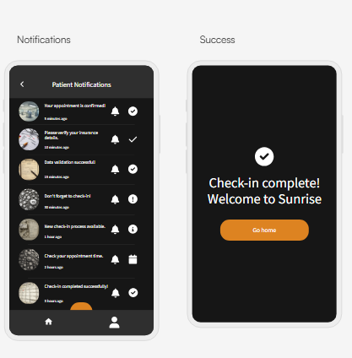
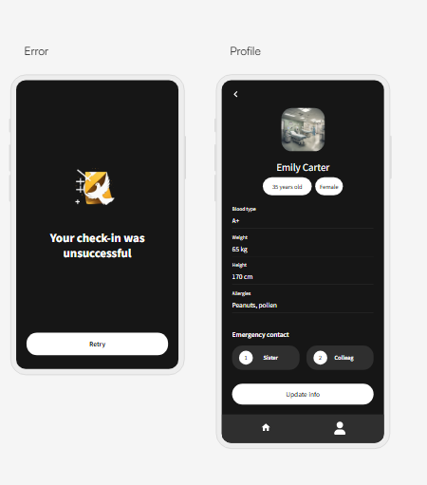
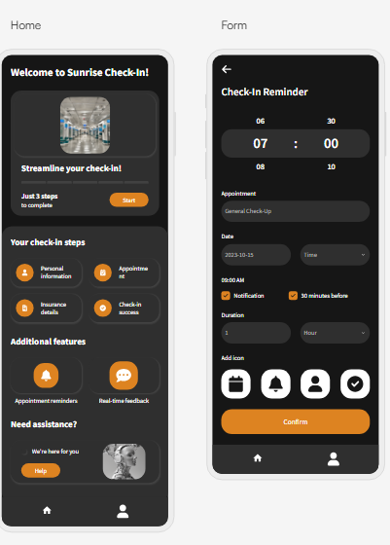
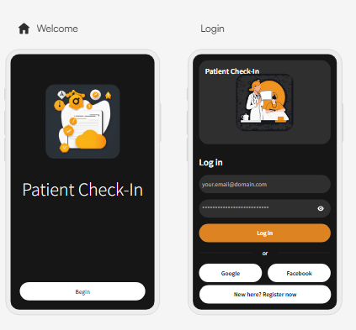

Conclusion
A well-designed input system is important when it comes to reducing check-in wait times and minimizing data entry errors at Sunrise Hospital. By structuring patient information into sections, implementing validation checks, and using user-friendly design features, this system ensures efficiency and accuracy. Addressing bottlenecks through step-by-step forms, automated data capture, and offline capabilities gives more usability. Overall, the proposed design supports the hospital’s goal of providing efficient, reliable, and patient-centered service.

References
GeeksforGeeks. (2024, July 4). User interface design. GeeksforGeeks. https://www.geeksforgeeks.org/software-engineering/software-engineering-user-interface-design/
Kendall, K. E., & Kendall, J. E. (2024). Systems Analysis & Design. Pearson.

